LARSA
"Larak" redirects here. For the administrative subdivision of Iran, see Larak Rural District.
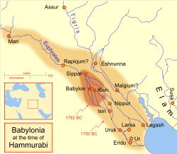
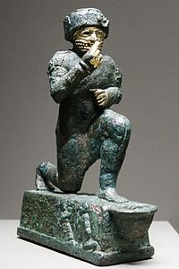
"The Worshipper of Larsa", a votive statuette dedicated to the god Amurrufor Hammurabi's life, early 2nd millennium BC, Louvre
Larsa (Sumerian logogram: UD.UNUG^{KI},^{[1]} read Larsam^{ki[2]}) was an important city of ancient Sumer, the center of the cult of the sun god Utu. It lies some 25 km southeast of Uruk in Iraq's Dhi Qar Governorate, near the east bank of the Shatt-en-Nil canal at the site of the modern settlementTell as-Senkereh or Sankarah.

History
According to the Sumerian king list, "Larag" (Sumerian: LA-RA-AK^{KI[3]}) was one of the five cities to "exercise kingship" in the legendary antediluvian era. The historical "Larsa" was already in existence as early as the reign of Eannatum of Lagash, who annexed it to his empire.
The city became a political force during the Isin-Larsa period. After the Third Dynasty of Ur collapsed ca. 1940 BC, Ishbi-Erra, an official of Ibbi-Sin, the last king of the Ur III Dynasty, relocated to Isin and set up a government which purported to be the successor to the Ur III dynasty. From there, Ishbi-Erra recaptured Ur as well as the cities of Uruk and Lagash, which Larsa was subject to. Subsequent Isin rulers appointed governors to rule over Lagash; one such governor was an Amorite named Gungunum. He eventually broke with Isin and established an independent dynasty in Larsa. To legitimize his rule and deliver a blow to Isin, Gungunum captured the city of Ur. As the region of Larsa was the main center of trade via the Persian Gulf, Isin lost an enormously profitable trade route, as well as a city with much cultic significance.
Gungunum's two successors, Abisare (ca. 1841 - 1830 BC) and Sumuel (ca. 1830 - 1801 BC), both took steps to cut Isin completely off from access to canals. After this period, Isin quickly lost political and economical force.
Larsa grew powerful, but it never accumulated a large territory. At its peak under king Rim-Sin I (ca. 1758 - 1699 BC), Larsa controlled only about 10-15 other city-states — nowhere near the territory controlled by other dynasties in Mesopotamian history. Nevertheless, huge building projects and agricultural undertakings can be detected archaeologically. After the defeat of Rim-Sin I by Hamurabi of Babylon, Larsa became a minor site, though it has been suggested that it was the home of the 1st Sealand Dynasty of Babylon.^{[4]}

Kings of Larsa
Ruler | Reigned (short chronology) | Comments
Naplanum | ca. 1961—1940 BC | Contemporary of Ibbi-Suen of Ur III
Emisum | ca. 1940—1912 BC
Samium | ca. 1912—1877 BC
Zabaia | ca. 1877—1868 BC | Son of Samium, First royal inscription
Gungunum | ca. 1868—1841 BC | Gained independence from Lipit-Eshtar of Isin
Abisare | ca. 1841—1830 BC
Sumuel | ca. 1830—1801 BC
Nur-Adad | ca. 1801—1785 BC | Contemporary of Sumu-la-El of Babylon
Sin-Iddinam | ca. 1785—1778 BC | Son of Nur-Adad
Sin-Eribam | ca. 1778—1776 BC
Sin-Iqisham | ca. 1776—1771 BC | Contemporary of Zambiya of Isin, Son of Sin-Eribam
Silli-Adad | ca. 1771—1770 BC
Warad-Sin | ca. 1770—1758 BC | Possible co-regency with Kudur-Mabuk his father
Rim-Sin I | ca. 1758—1699 BC | Contemporary of Irdanene of Uruk, Defeated by Hammurabi of Babylon, Brother of Warad-Sin
Hammurabi of Babylon | ca. 1699—1686 BC | Official Babylonian rule
Samsu-iluna of Babylon | ca. 1686—1678 BC | Official Babylonian rule
Rim-Sin II | ca. 1678—1674 BC | Killed in revolt against Babylon

Archaeology
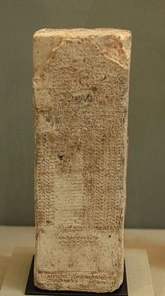
List of the kings of Larsa, 39th year ofHammurabi's reign, Louvre
The remains of Larsa cover an oval about 4.5 miles in circumference. The highest point is around 70 feet in height.
The site of Tell es-Senkereh, then known as Sinkara, was first excavated by William Loftus in 1850 for less than a month.^{[5]} In those early days of archaeology, the effort was more focused on obtaining museum specimens than scientific data and niceties like site drawings and findspots were not yet in common usage. Loftus recovered building bricks of Nebuchadnezzar II of the Neo-Babylonian Empire which enabled the sites identification as the ancient city of Larsa. Much of the effort by Loftus was on the temple of Shamash, rebuilt by Nebuchadnezzar II. Inscriptions of Burna-Buriash II of theKassite dynasty of Babylon and Hammurabi of the First Babylonian Dynasty were also found. Larsa was also briefly worked by Walter Andrae in 1903. The site was inspected by Edgar James Banks in 1905. He found that widespread looting by the local population was occurring there.^{[6]}
The first modern, scientific, excavation of Senkereh occurred in 1933, with the work of Andre Parrot.^{[7][8]} Parrot worked at the location again in 1967.^{[9]}In 1969 and 1970, Larsa was excavated by Jean-Claude Margueron.^{[10][11]} Between 1976 and 1991, an expedition of the Delegation Archaeologic Francaise en Irak led by J-L. Huot excavated at Tell es-Senereh for 13 seasons.

